Derived Tables

## Sub-Query in From Clause or Also known as Inline Views or Also known as Derived Tables

Whenever derived columns are going to be required again & again in the output with some different results, then repeating the same expression again & again will be tedious & re parsing effort will be there.

**Example 1:**

selectename,sal,comm,

sal+isnull(comm,0.30*Sal)asTotal,

(sal+isnull(comm,0.30*Sal))*0.5as"50% Less",

(sal+isnull(comm,0.30*Sal))*0.4as"40% Less",

(sal+isnull(comm,0.30*Sal))*0.3as"30% Less"

fromemp;

The expression (sal+isnull(comm,0.50*Sal)) is getting repeated again & again, (not good)

Instead of this, the expression can be defined **once** in the derived table & then further can be used **as a column itself** **in the main select statement in the column list, or where clause or group by clause or having clause !!!!**

selectename,sal,comm, **total**,

**total** *0.5as"50% Less",

**total** *0.4as"40% less",

**total** *0.30as"30% Less"

from (selectename,sal,comm,

**sal + isnull(comm, 0.30 * Sal) as total** fromemp) **e**;

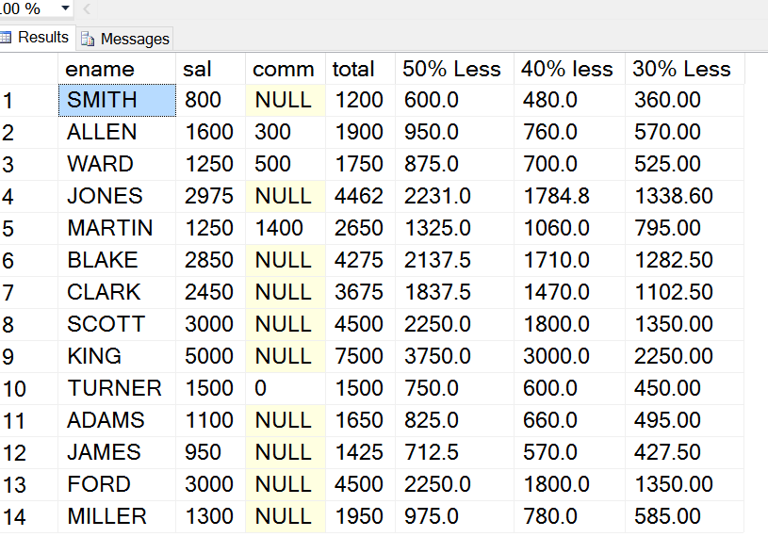

**Example 2:**

|  |
| --- |
| selectename,sal,Bonus,sal+Bonusas"Total Extra",  Bonus+2000as"Arrears", (sal+Bonus)*0.02asTax  from (selectename,sal,  casewhensal>=5000then (0.10*sal)  whensal>=3000then (0.20*sal)  whensal>=2000then (0.30*sal)  whensal>=1000then (0.40*sal)  else  (0.50*sal)  endasBonus  fromemp)e; |

**Example 3:**

--Example 3: Derived Column logic getting repeated in Column List & Group By clause

Select Case

When Year(Hiredate) = 1980 then 'In First Year'

When Year(Hiredate) = 1981 then 'In Second Year'

When Year(Hiredate) = 1983 then 'In Third Year'

Else

'Above third year'

End as "Year of Joining", sum(sal) as Total

from emp

Group by Case

When Year(Hiredate) = 1980 then 'In First Year'

When Year(Hiredate) = 1981 then 'In Second Year'

When Year(Hiredate) = 1983 then 'In Third Year'

Else

'Above third year'

End

-- Writing the Case function in the derived table to eliminate redundancy

Select "Year of Joining", Sum(sal) as Total

from (Select Case

When Year(Hiredate) = 1980 then 'In First Year'

When Year(Hiredate) = 1981 then 'In Second Year'

When Year(Hiredate) = 1983 then 'In Third Year'

Else

'Above third year'

End as "Year of Joining", Sal

From Emp

) as E

Group By "Year of Joining"

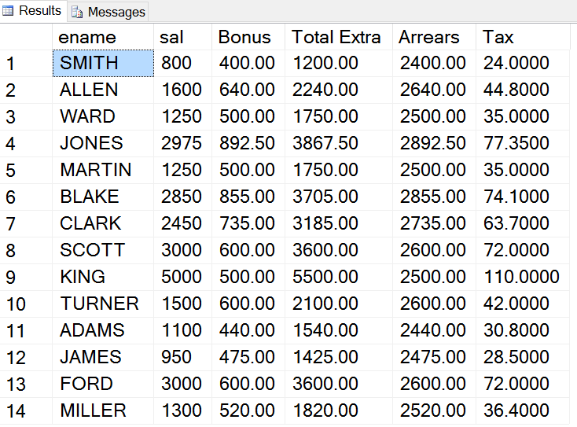

**Valid Column Combination Hints**

|  |  |  |
| --- | --- | --- |
| **Combination** | **Technique to be used** | **Example** |
| AF + GC | Group By | Select deptno,max(sal) from emp  Group by deptno |
| AF + NGC | Sub Query | Select ename,sal from emp  Where sal = (select max(sal) from emp) |
| AF +GC +NGC + Expressions (if any) | From Clause Query/Derived Table/Inline View |  |

**Example 1 –**

AF 🡪 Aggregate Function

NGC 🡪 Non group able column

GC 🡪 Group able column

**To see names, salaries, job, average salary and difference (raise) with average salary of those employees who earn more than the average salary in their jobs.**

SELECT a.ename, a.sal, a.job, b. SalAvg, a.sal-b. SalAvg as "Raise"

**FROM emp a INNER JOIN (SELECT job,**

**AVG(sal) as SalAvg**

**FROM emp**

**GROUP BY job) b**

ON a.job = b.job

WHERE a.sal > b. SalAvg;

**Example 2 –**

Display the name, sal, deptno, highest sal and difference of employees who are earning sal less than the highest of their own deptno

Select E.Ename, E.Sal, E.Deptno, D.Highest, D.Highest-E.Sal as Less

From Emp E Join (Select Deptno, max(sal) as Highest

From emp

Group By Deptno) D

On E.Deptno = D.Deptno

Where E.Sal < D.Highest

**Top-N Analysis with Derived Tables or Inline views;**

Another area where sub query in from clause can be used is for performing **Top-N Analysis.**

**1) To see the first 3 highest salary records**

Select E.*

from (select Distinct Top 3 Sal From emp Order By sal Desc) **Top3** Join **Emp E**

On Top3.Sal = E.Sal

Order By Sal Desc

**2) To display the fourth highest salary**

Select min(Sal) from (select Distinct Top 4 Sal From emp Order By sal Desc) S

-- Display the record of only 4th highest salary earner

Select*fromemp

wheresal= (Selectmin(Sal)

from (selectDistinctTop4Sal

Fromemp

OrderBysalDesc)S

)

**3) To display the fourth lowest salary**

Select max(Sal) from (select Distinct Top 4 Sal From emp Order By sal) S